Welcome To Pre-K
2023-2024 Supply List
1 backpack (no wheels)
1 reusable snack bag and lunch box
1 snap lock (leak proof) water bottle
1 smock in a labeled Ziplock plastic bag
2 boxes of thick pencils
1 plastic pencil box
2 plastic folders
1 Ream of White Computer paper
1 box of washable Crayola Thick Markers
2 black Expo markers and eraser
2 boxes Jumbo Crayola Crayons- 8 Count
2 jumbo Elmer’s glue sticks
1 Bottle of Elmer’s school glue
1 Fiskars Preschool Learn to Cut Scissors
2 boxes of tissues
1 box of non-scented baby wipes
1 box of large Ziplock bags
1 roll of paper towels
1 Large container of Clorox Wipes
1 bottle of soap and 1 large bottle of hand sanitizer
1 family picture and 1 individual picture
Cubby Clothes- All Labeled with Name
1 Large Labeled Ziplock Bag of Change of Clothes (Underwear, sweatpants, tee shirt, socks, shoes)
For Rest Time- Blankets and Sheets will Be Sent home at the end of the week for cleaning
1 Nap Mat
1 Twin Size fitted sheet (Not crib size please)
1 Medium Reusable Duffle bag for sheets, (please make sure it opens and closes easy with bedding inside).

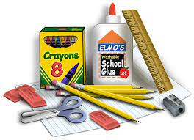
Kindergarten Supply List

1 Backpack (No Wheels)
2 packs of #2 pencils Pre-Sharpened (24 or 30 count)
1 box of 24 Crayola Crayons
3 box of Black Expo Markers
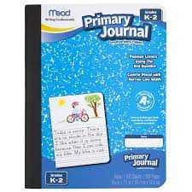
1 Red Plastic 2 Pocket Folder
1 Blue Plastic 2 Pocket Folder
1 Yellow Plastic 2 Pocket Folder
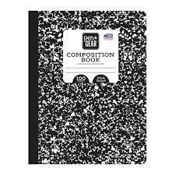
1 Green Plastic 2 Pocket Folder
1 Purple Plastic 2 Pocket Folder
2 Black Wide Ruled Composition Notebooks
2 Black Primary Ruled Composition Notebooks
2 Bottles of Clorox Wipes
2 Packages of Baby Wipes
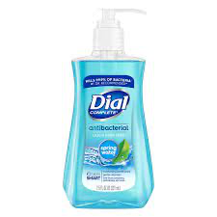
2 Bottles of Hand Sanitizer
2 Rolls of Paper Towels
4 Boxes of Tissues
2 Bottles of Hand Soap
1 Box of 1 Gallon Zip Lock Bags
1 Box of Quart Ziplock Bags
Change of clothes in a Ziplock Bag (labeled with your child’s name)
1 Pair of Child’s Headphones in a Ziplock Bag (Labeled with your child’s name)

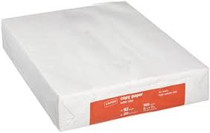
$10.00 to purchase Reams of Paper

First Grade Supply List 2023-2024
Girls: A yellow blouse and a navy skirt/ pants
Boys: A yellow shirt and navy-blue pants/sweatpants Sneakers should be worn everyday (Velcro if children cannot tie shoes)
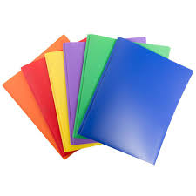  3 plastic folders  (blue, red, orange | 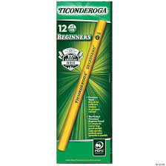  3 packs of Ticonderoga pre- sharpened pencils | 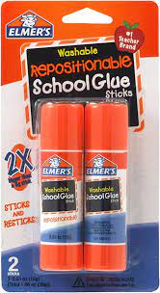  2 packs of glue sticks | 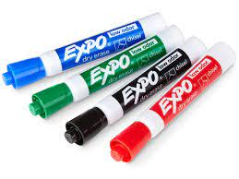  2 packs of dry erase Expo Markers
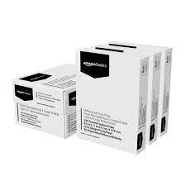  3 reams of printer paper | 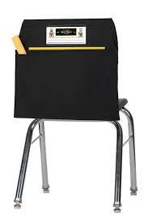  Please send in $15 for a seat sack that each teacher will order for their class. | 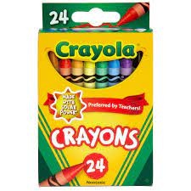  1 pack of 24 crayons | 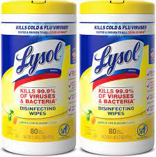  2 tubes of Clorox wipes
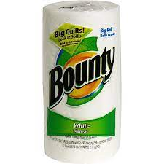  1 roll of paper towel | 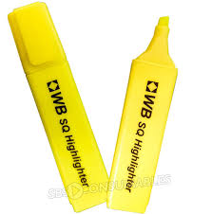  1 pack of highlighters | 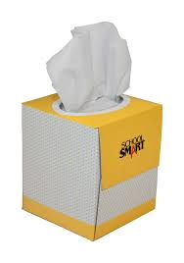  A box of tissues | 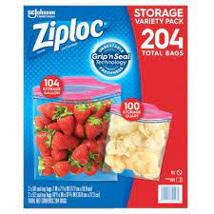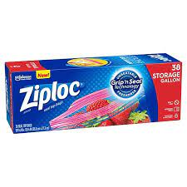  1 gallon of Ziploc bags and 1 quart size Ziploc bags
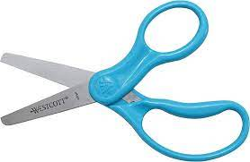  A pair of scissors  ** | 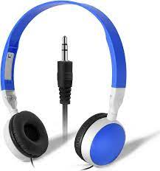  A set of headphones  ** | 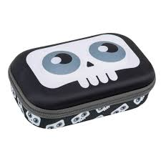A soft pencil case that can fit their pencils, crayons, glue, and scissors  ** | 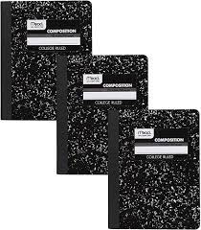  3 notebooks  1 blue, 1 red, and 1 black and white  **
** Please label ONLY these items with your child’s first and last name.

P.S. 176Q Grade 2
Welcome to Second Grade! 2023 – 2024 Supply List
Individual Supplies: Labeled with your child’s name.
- 1 headset with mic (No wireless/Bluetooth)
- $15 for Scholastic News subscription and seat sacks
- 6 marble notebooks
- 5 two pocket folders (plastic only)
- 1 large soft pencil case (supplies should fit inside the pencil case)
o 1 yellow highlighter
o 2 large glue stick (no liquid glue please) o 1 large eraser
o 1 pair of kid scissors
o 2 boxes of 24 Crayola crayons
o 1 pack of 12 colored pencils
o 1 covered pencil sharpener
Class Supplies: No label necessary
- 2 Boxes of 12 sharpened pencils (no mechanical pencils please)
- 3 Reams of copy paper
- 2 Boxes of black Expo dry erase markers
- 2 Boxes of Kleenex tissues
- 2 Rolls of paper towels
- 1 Box of gallon size Ziploc bags
- 1 Box of quart size Ziploc bags
- 1 Bottle of hand sanitizer
- 1 Bottle of liquid hand soap
- 2 containers of disinfectant wipes
- 1 pack of lined post its (6” x 4”)
- 1 pack of loose-leaf paper
- 1 pack of construction paper
- 1 ruler (inch and cm)

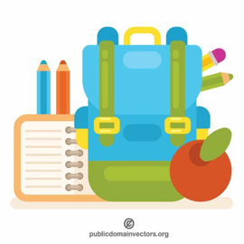Grade 3 Supply List 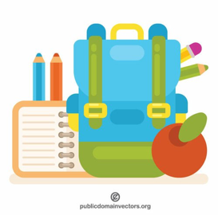
2023-2024

- Zipper pencil pouch
- 2 packs of pre-sharpened Ticonderoga pencils
- 1 box of 24 Crayola crayons
- 1 box of 12 Crayola colored pencils
- 1 pack of 2 black sharpies
- 1 covered pencil sharpener
- 1 pair of scissors
- 2 jumbo glue sticks
- 1 roll of packing tape
- 1 box of staples
- 1 box of black dry erase markers
- 1 dry erase eraser
- 7 marble notebooks
- 7 folders
- 1 pack of lined Post-Its
- 1 headset with cord to plug into devices
- 1 container of Anti-bacterial wipes or Lysol/Clorox wipes
- 1 paper towel roll
- 2 boxes of tissues
- 1 box of gallon sized zip-lock bags
- 1 box of sandwich sized zip-lock bags
- 1 Hand soap with pump
- 1 Antibacterial with pump
- 2 reams of white copy paper
- 1 pack of loose leaf paper

Grade 4 Supply List
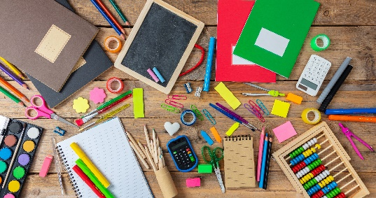
2023-2024

- Zipper pencil pouch/Case
- 2 packs of pre-sharpened Ticonderoga pencils
- 1 box of 24 Crayola crayons
- 1 box of 12 Crayola colored pencils
- 1 pack of 2 black sharpies
- 1 covered pencil sharpener
- 1 pair of scissors
- 2 jumbo glue sticks
- 1 roll of packing tape
- 1 box of staples
- 1 box of black dry erase markers with an old clean sock
- 1 dry erase eraser
- 7 composition notebooks
- 7 sturdy plastic folders
- 1 pack of lined Post-Its
- 1 headset with cord to plug into devices (Put inside a Ziploc bag labeled with their name)
- 1 container of Anti-bacterial wipes or Lysol/Clorox wipes
- 1 paper towel roll
- 2 boxes of tissues
- 1 box of gallon sized zip-lock bags
- 1 box of sandwich sized zip-lock bags
- 1 Hand soap with pump
- 1 Antibacterial with pump
- 2 reams of white copy paper
- 1 pack of loose leaf paper

